Label Encoding for Text Categories

Definition
# Source: AI Source: Provided by: [Data Path: Persons Table -> ID Column: 1, Name_En Column: Motasem Essam] -> From: [ChatGPT] on [12/10/2025]
Label Encoding is a text encoding technique that converts categorical text labels into numerical values. Each unique category is assigned a unique integer, making it suitable for machine learning models that require numerical input.

Key Idea
# Source: AI Source: Provided by: [Data Path: Persons Table -> ID Column: 1, Name_En Column: Motasem Essam] -> From: [ChatGPT] on [12/10/2025]
Many algorithms cannot process text labels directly, so label encoding transforms them into numbers while preserving category identity, not order.

How It Works
# Source: AI Source: Provided by: [Data Path: Persons Table -> ID Column: 1, Name_En Column: Motasem Essam] -> From: [ChatGPT] on [12/10/2025]
- Identify all unique categories in the dataset.
- Assign a unique integer to each category.
- Replace the text labels with the corresponding numeric values.

Example
# Source: AI Source: Provided by: [Data Path: Persons Table -> ID Column: 1, Name_En Column: Motasem Essam] -> From: [ChatGPT] on [12/10/2025]
Original dataset:
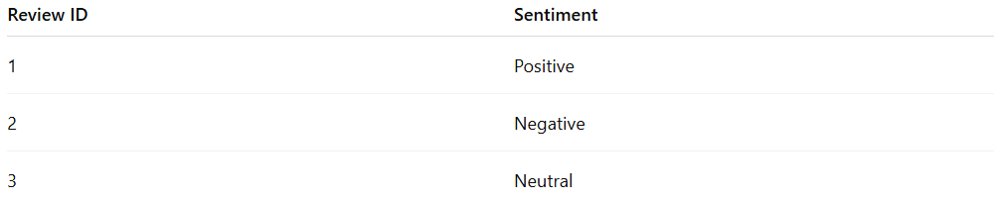
Review ID | Sentiment
1 | Positive
2 | Negative
3 | Neutral
Label Encoding:
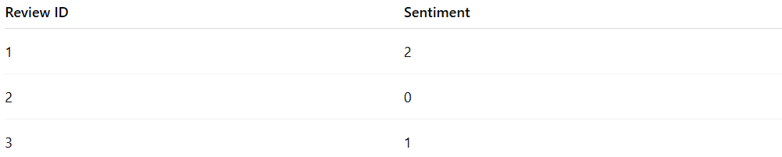
Review ID | Sentiment
1 | 2
2 | 0
3 | 1
- Mapping: Negative → 0, Neutral → 1, Positive → 2

Applications
# Source: AI Source: Provided by: [Data Path: Persons Table -> ID Column: 1, Name_En Column: Motasem Essam] -> From: [ChatGPT] on [12/10/2025]
- Converting categorical labels for classification tasks
- Preprocessing text categories for machine learning algorithms
- Used in target encoding for supervised learning

Advantages
# Source: AI Source: Provided by: [Data Path: Persons Table -> ID Column: 1, Name_En Column: Motasem Essam] -> From: [ChatGPT] on [12/10/2025]
- Simple and easy to implement
- Converts categorical labels into numerical form
- Compatible with most machine learning algorithms

Disadvantages
# Source: AI Source: Provided by: [Data Path: Persons Table -> ID Column: 1, Name_En Column: Motasem Essam] -> From: [ChatGPT] on [12/10/2025]
- Introduces ordinal relationships where none exist (e.g., 0 < 1 < 2)
- Not suitable for features with no inherent order, as it may bias the model
- Should be combined with one-hot encoding for nominal categories in some cases

